Lab 03: Using LiveBindings
FMX Mobile Application Development
- Add a TPrototypeBindSource
  - Dbl Click -> Add ContactBitmapsL & ContactNames
- Add TListView
  - Find the ItemAppearance.ItemAppearance property
    - Change it from ListItem to ImageListItem
  - Set ItemAppearanceObjects.ItemObjects.Visible to False
- Right Click ListView1 -> Bind Visually…
  - Connect:
    - Sync -> *
    - Item.Text -> ContactName1
    - Item.Bitmap -> ContactBitmatL1

Open the LiveBindings Designer from either the View menu or by right-clicking on your form/components.

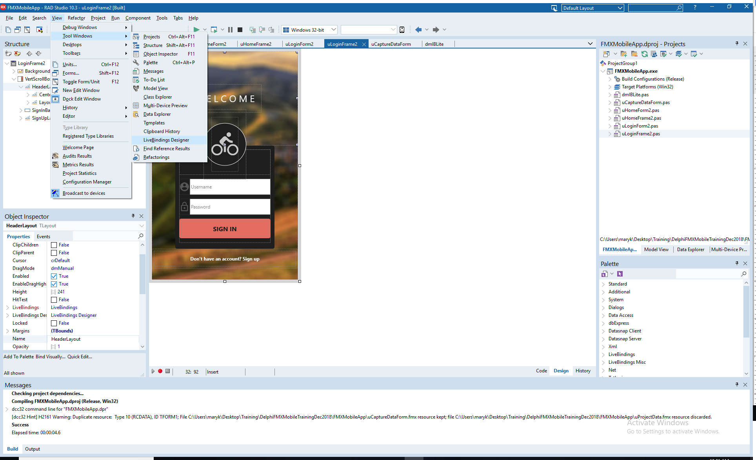
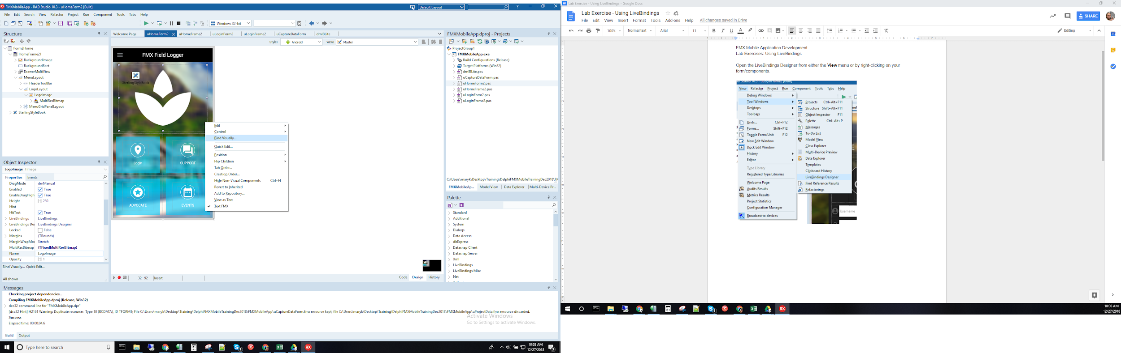
In the LiveBindings Designer, your binding diagram contains just the objects and you are ready to link them.

